**Assignment - 2**

**Name:** PAMARTHI LAKSHMI DURGA

**Roll no:** 23485A5410

**Branch:** Artificial Intelligence & Data Science

**College Name:** Seshadri Rao Gudlavalleru Engineering College

***Donut Chart***

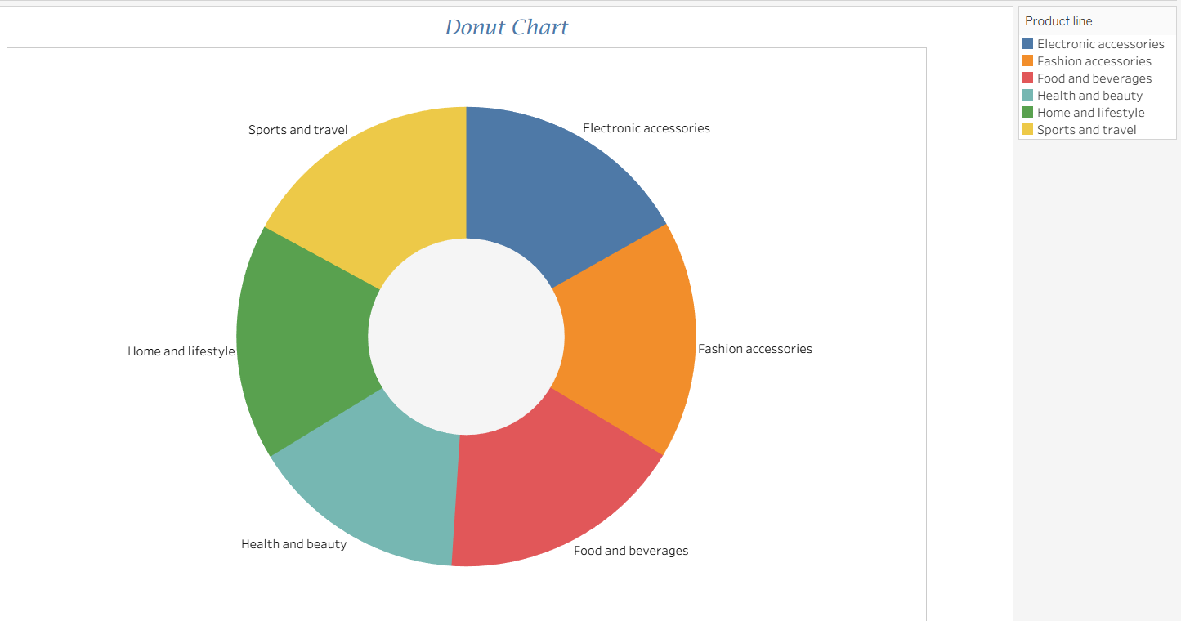

***Area Chart***

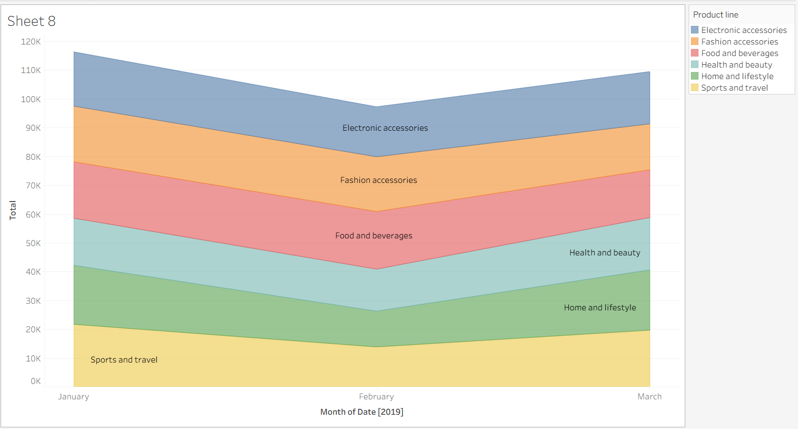

***Text Table***

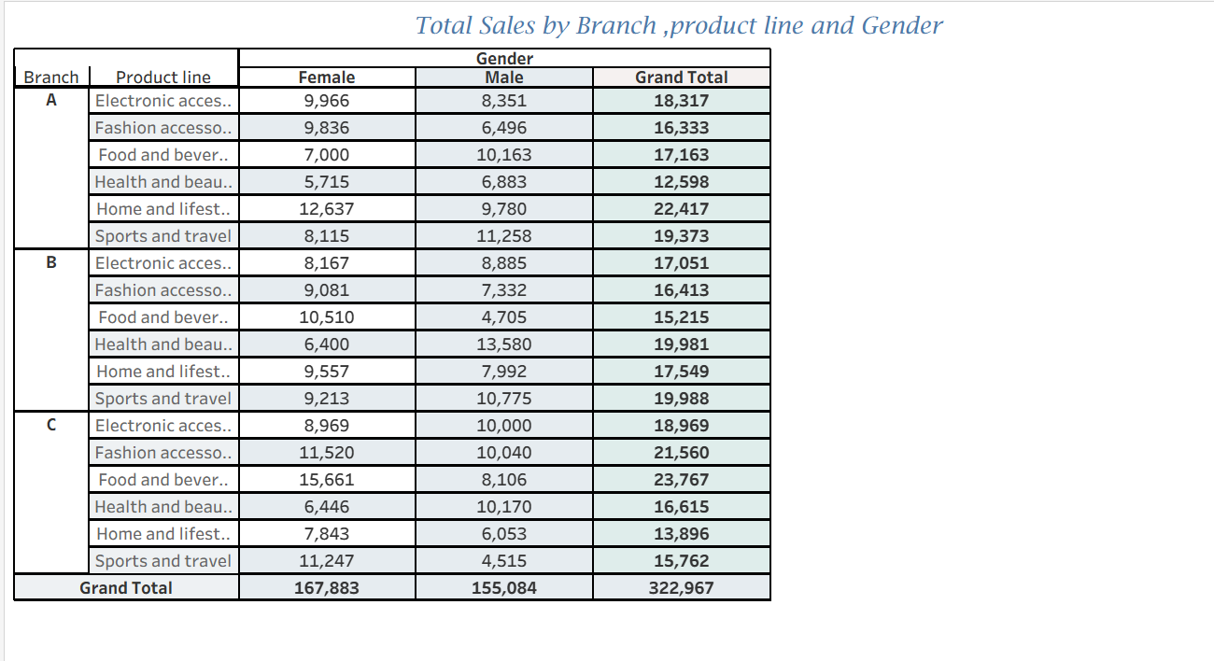

***Highlighted Table***

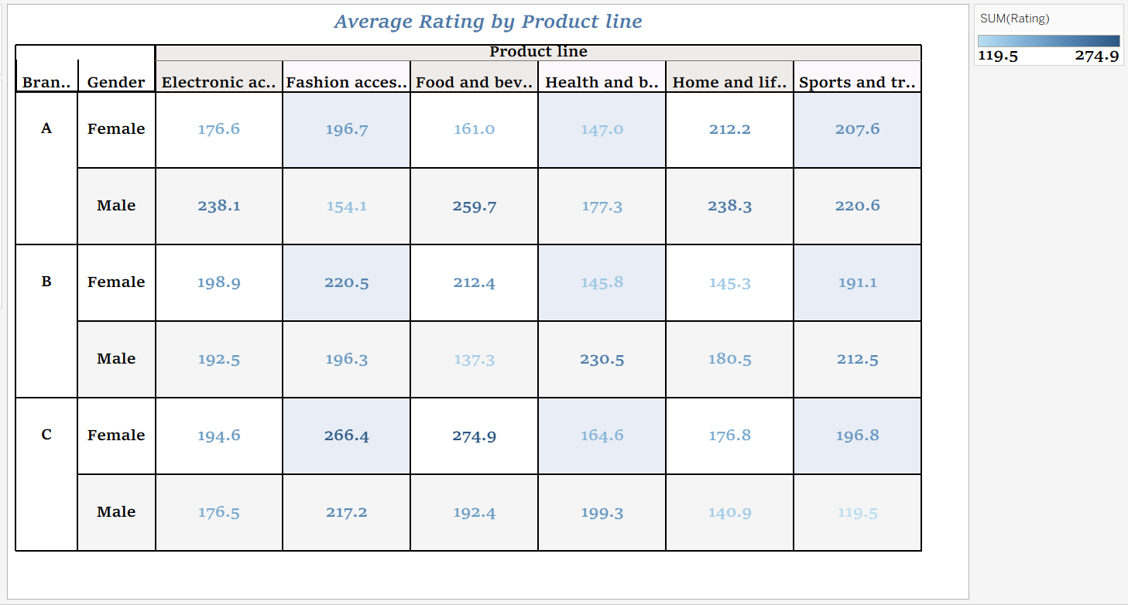

***Word cloud***

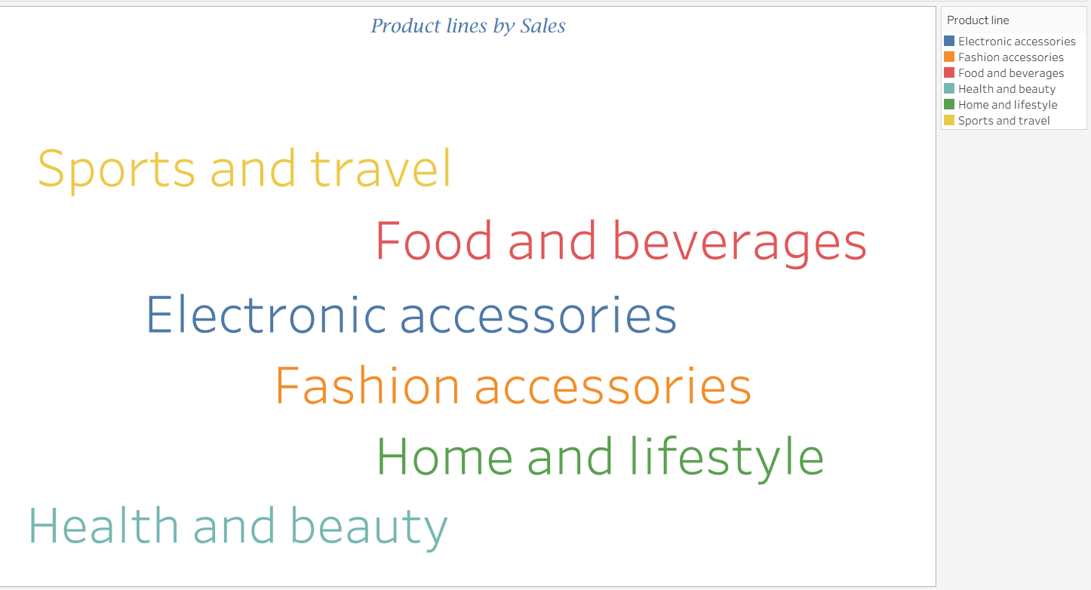

***Funnel Chart***

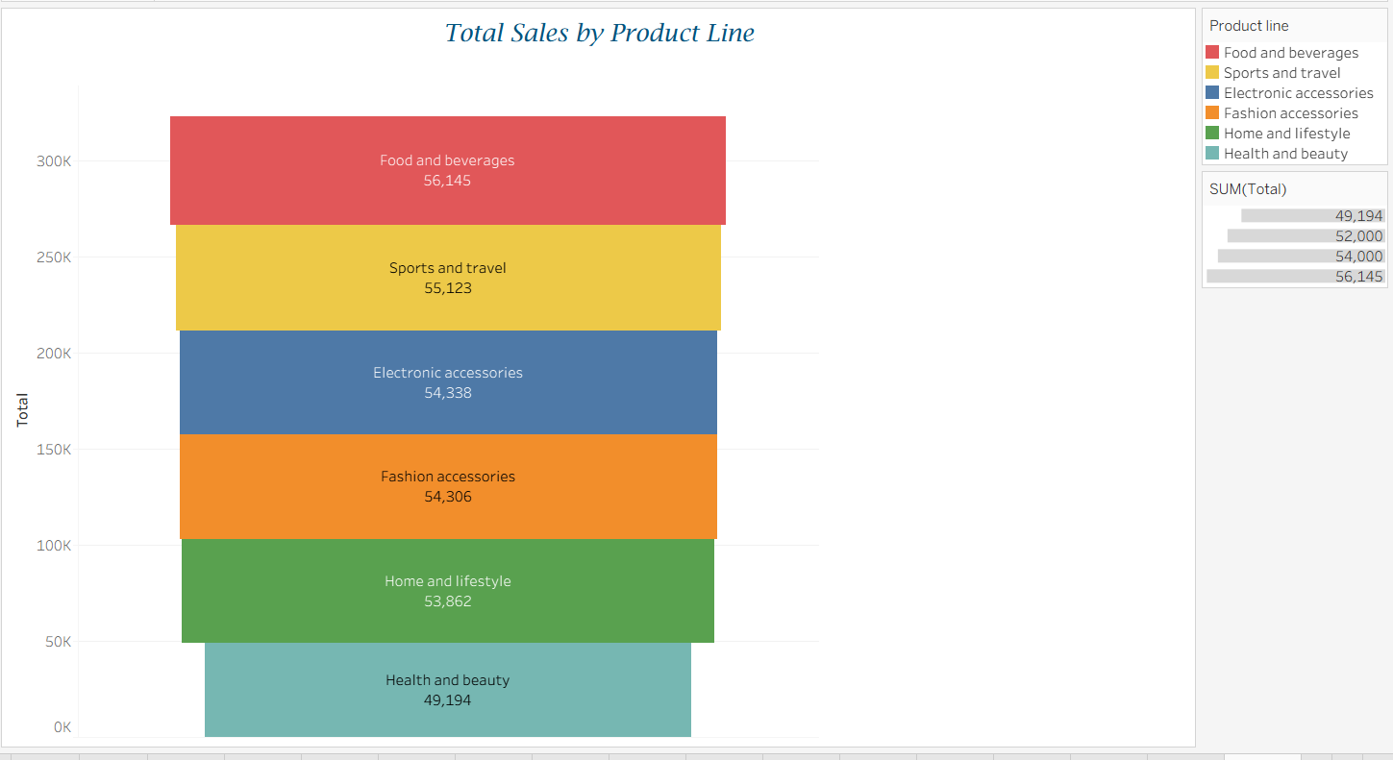

***Waterfall Chart***

